Communicational / Informational Cohesion

📌 Definition:
# Source: AI Source: Provided by: [Data Path: Persons Table -> ID Column: 1, Name_En Column: Motasem Essam] -> From: [Chatgpt (GPT‑5 Mini)] on [12/9/2025]
Communicational (Informational) Cohesion occurs when elements of a class/module operate on the same data or contribute to the same output.

🧠 Simple idea:
# Source: AI Source: Provided by: [Data Path: Persons Table -> ID Column: 1, Name_En Column: Motasem Essam] -> From: [Chatgpt (GPT‑5 Mini)] on [12/9/2025]
“Different operations, same data” 📊

🔍 Key characteristics:
# Source: AI Source: Provided by: [Data Path: Persons Table -> ID Column: 1, Name_En Column: Motasem Essam] -> From: [Chatgpt (GPT‑5 Mini)] on [12/9/2025]
- 🧩 Methods work on shared data
- 📊 Focus is on one data set or structure
- 🟢 Good level of cohesion (but less than functional)
- ⚙️ Common in data-handling classes

📊 Example:
# Source: AI Source: Provided by: [Data Path: Persons Table -> ID Column: 1, Name_En Column: Motasem Essam] -> From: [Chatgpt (GPT‑5 Mini)] on [12/9/2025]
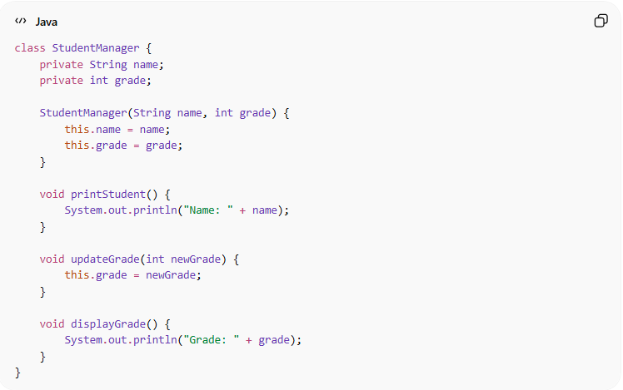
class StudentManager {
private String name;
private int grade;

StudentManager(String name, int grade) {
this.name = name;
this.grade = grade;
}

void printStudent() {
System.out.println("Name: " + name);
}

void updateGrade(int newGrade) {
this.grade = newGrade;
}

void displayGrade() {
System.out.println("Grade: " + grade);
}
}
- ✅ All methods operate on the same data (student info)
- ✅ Different tasks, but same data context → communicational cohesion

🛡️ Avoiding Communicational / Informational Cohesion Example:
# Source: AI Source: Provided by: [Data Path: Persons Table -> ID Column: 1, Name_En Column: Motasem Essam] -> From: [Chatgpt (GPT‑5 Mini)] on [12/9/2025]
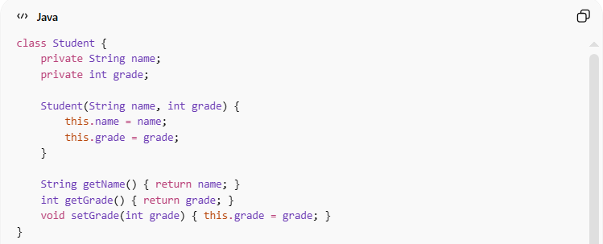
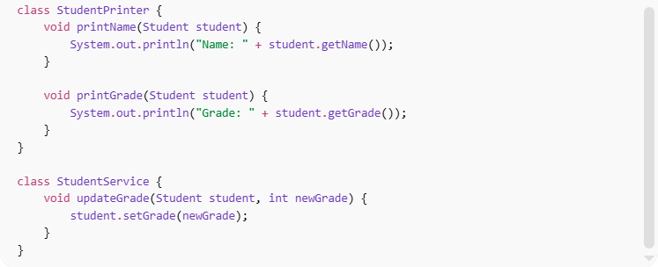
class Student {
private String name;
private int grade;

Student(String name, int grade) {
this.name = name;
this.grade = grade;
}

String getName() { return name; }
int getGrade() { return grade; }
void setGrade(int grade) { this.grade = grade; }
}

class StudentPrinter {
void printName(Student student) {
System.out.println("Name: " + student.getName());
}

void printGrade(Student student) {
System.out.println("Grade: " + student.getGrade());
}
}

class StudentService {
void updateGrade(Student student, int newGrade) {
student.setGrade(newGrade);
}
}
Usage:
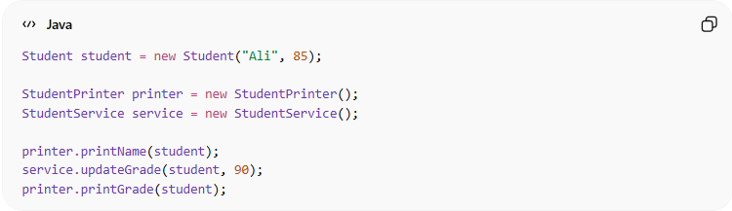
Student student = new Student("Ali", 85);

StudentPrinter printer = new StudentPrinter();
StudentService service = new StudentService();

printer.printName(student);
service.updateGrade(student, 90);
printer.printGrade(student);
✅ Key improvements:
- 🧩 Responsibilities are separated into different classes
- 🎯 Each class has a clear, single purpose
- 🔄 Easier to modify or extend independently
- ⚙️ Improves maintainability and scalability

⚙️ Best Practice:
# Source: AI Source: Provided by: [Data Path: Persons Table -> ID Column: 1, Name_En Column: Motasem Essam] -> From: [Chatgpt (GPT‑5 Mini)] on [12/9/2025]
- Keep methods focused on the same data set
- Avoid adding unrelated responsibilities
- Split class if it grows too large
- Maintain clear data ownership

